**DATA1002 Report**

Group : **L19-G4**

Members :

(aguo4791, 520644847)

(rcha0546, 520392823)

({slpa9090},{500545654})

(npai5889,520617829)

**Table of Contents**

**1. Introduction** **4**

**2. Report Scope** **4**

2.1 Report Topic 4

2.2 Report Stakeholders 4

2.3 Report Relevance 4

**3. Chosen Datasets** **6**

3.1 Transport Stops 6

3.1.1 Transport Dataset Explanation 6

3.1.2 Transport Dataset Quality Assurance 7

3.1.3 Transport Dataset Python Analysis Description 7

3.2 Criminal Activity 8

3.2.1 Crime Dataset Explanation 8

3.2.2 Crime Dataset Quality Assurance 8

3.2.3 Crime Dataset Python Analysis Description 11

3.3 Income 12

3.3.1 Income Dataset Explanation 12

3.3.2 Income Dataset Quality Assurance 13

3.3.3 Income Dataset Python Analysis Description 14

3.4 Immunisation Rates 17

3.4.1 Health Dataset Explanation 17

3.4.2 Health Dataset Quality Assurance 18

3.4.3 Health Dataset Python Analysis Description 18

**4. Data Integration** **19**

**5. References** **22**

**Appendices** **23**

A.1 Transport Dataset Links 23

B.1 Transport Dataset Cleaning 23

B.2 Crime DataSet Cleaning 23

B.2.1 23

B.2.2 24

B.2.3 24

B.2.4 24

B.2.5 25

B.4 Health DataSet Cleaning 25

C.1 Transport Dataset Analysis 26

C.2 Crime Dataset Analysis 27

C.4 Health Dataset Analysis 27

D. Converting to integer types 28

E.1 28

F.1 28

G.1 Description of NP values 29

G.2 Income cleaning code 29

G.3 Income Summary 1. 29

G.3 Income Summary 2. 30

G.3 Income Summary 3. 30

H.1 View of integrated dataset 30

H.2 Python Code 31

# **1. Introduction**

The problem of quality of life has persisted as long as civilization has stood. In every society, there are large disparities in income, access to basic goods and services, level of health etc. among other things across its people [1]. These factors can be quantified and used to explain the expected quality of life for a given area.

This report will entail the factors in play for an individual’s quality of life, explain usage of datasets gathered and how they combine to explain data trends in NSW and Sydney City.

# **2. Report Scope**

## 2.1 Report Topic

The question addressed in this report is - “How do different factors and indicators play a role in determining an individual’s quality of life in NSW?”. We aim to answer this question by quantifying and integrating relevant datasets giving us a numeric approach to a solution.

UNICEF [2] identified that personal security, income, health and access to transport were important quality of life indicators. Following this, we used our own datasets that followed this theme. These 4 identifiers we focused on throughout the report were, access to transport stops, level of criminal activity, income and immunisation rates throughout NSW.

## 2.2 Report Stakeholders

There are many possible users of this report, but we expect and intend to reach the following stakeholders the most :

* Government officials/Policy makers with power
* Advocacy groups and caregivers
* Health workers such as Doctors
* Students wanting to learn about data science
* Individuals interested in quality of life

All these individuals have somewhat of a stake in measuring people’s quality of life, and through the use of this report, they will gain insight on important information affecting society. By finding some relevant analysis, policy makers will be able to implement change and decrease the gap in quality of life, advocacy groups can endorse activism and students can gain data analysis experience etc.

## 2.3 Report Relevance

As stated previously, a main identifier we used was transport accessibility which affects the ease of access an individual has to travel. The more accessibility, the more convenient one’s life becomes. Secondly, we had criminal activity as another indicator, which affects the daily lives of those in the community, for example an individual living in high crime areas may pay more for security purposes. Additionally, we used income as an indicator which affects an individual’s level of spending and access to goods. Lastly, we used immunisation rates as an indicator of health, where the higher immunisation rate meant better health in general and less diseases.

Note that the **independent data origination** was maintained for this analysis by choosing datasets from different organisations, collected for different purposes (i.e. Transport data was extracted from Transport for NSW, Security Data was extracted from Australian, Health Data was collected from the Australian Institute of Health and Welfare Institute Income data was collected by the Australian Taxation Office). See Section 3 for better breakdown.

# **3. Chosen Datasets**

The following section details the identifier datasets chosen and the members responsible.

## 3.1 Transport Stops

520644847 was responsible for the handling of transport data. Explored here is the relationship between accessibility to transport services and quality of life. A strong correlation exists between quality of life and transport access, as access to such facilities creates convenience in an individual’s day to day life.

### 3.1.1 Transport Dataset Explanation

The used dataset was of a .txt format, containing columns separated by commas. Structured in a wide format schema, the postcode data was extracted from ‘stop_id’, as these represent what postcode the stop resides [3]. The dataset dictionary is as follows :

| **Field name** | **Data type** | **Description** | **Example** |
| --- | --- | --- | --- |
| stop_id | Integer | An ID that uniquely identifies a stop or station | 287145 |
| stop_code | Integer | An ID that uniquely identifies a stop or station for passengers | 287145 |
| stop_name | Text | The name of the stop or station | Oxford St After Wambat St |
| stop_lat | Float | Latitude of the stop | -33.3927530382903 |
| stop_lon | Float | Longitude of the stop | 148.008175550113 |
| location_type | Integer | 0 or blank represents a stop and 1 represents a station | 1 |
| parent_station | Text | For stops that are inside stations, this field identifies the station associated with the stop | PST1181 |
| wheelchair_boarding | Integer | 0 or blank represents no information, 1 represents some vehicles can take wheelchairs and 2 represents wheelchair boarding is not possible | 2 |
| platform_code | Integer | The platform number if this stop belongs to a station | 7 |

*Figure 1 : Data dictionary showing metadata information on transport dataset*

More metadata information : created by TransportNSW on 18/03/19 of size 4.3MB

This dataset was found via public datasets available on transitfeeds[1], collated from open datasets made available by the original collector of the data, TransportNSW. It is stated by TransportNSW that this dataset is of access level public, and no restrictions on use of this data have been made. The link to this dataset can be found in Appendix A.1.

Furthermore, the dataset used had limitations to its use, such as the inconsistencies with the stop IDs. Stop IDs in this dataset indicate the postcode, but after data cleaning random letters were found to be in a few of the stop IDs - these were discarded. Additionally, most if not all of the location types were incorrectly identified. Train stations were not labelled as such and most data points did not even have a location type referenced. This was avoided by choosing to sum all stops and stations, instead of separating the two during the data cleaning process. Contrastingly, the main strength of this dataset is the abundance of observations available, and the straightforward comprehensibility it has.

### 3.1.2 Transport Dataset Quality Assurance

The data was cleaned using Python and pandas. During the first iterations of data cleaning the location type was used to store the count of bus stops and train stations, with the key being the postcodes. However, as the dataset provided unreliable information on the location type, this was later changed to instead sum all stops and stations for a postcode. Additionally, several stop IDs were incorrectly filled and therefore unusable - these were filtered out by checking if it was an integer or not. The code for this cleaning can be found in appendix B.1.

### 3.1.3 Transport Dataset Python Analysis Description

The data summary for this dataset was compiled using Python code and pandas. It was separated to show data summaries for Sydney City (2000-2011), NSW excluding Sydney City (2012-2786) and all of NSW (2000-2786). This was done by recording to 3 separate dictionaries the total stops per area, then converting them to pandas dataframes and collecting the summaries using ‘.dictionary()’. This method is fully specified in Appendix C.1.

The data summaries are as follows :

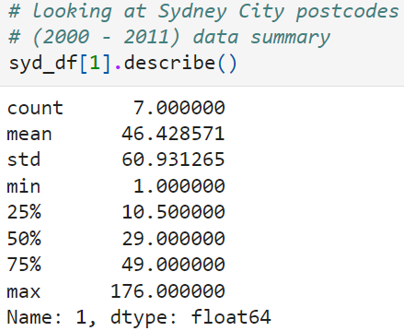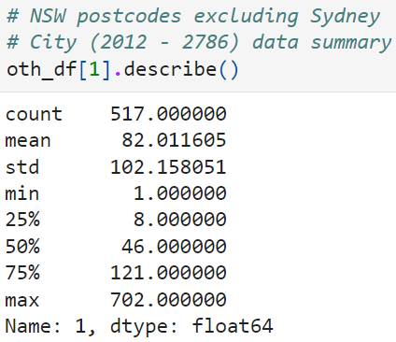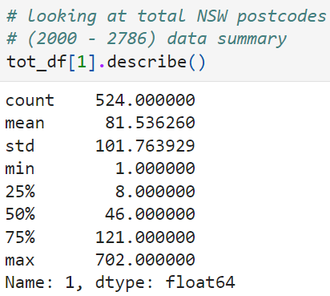

*Figure 2 : Data summaries of transport dataset*

## 3.2 Criminal Activity

520392823 was responsible for the handling of the crime data.

This data explores the relationship between crime and quality of life. Crime is a suitable indicator of quality of life, the lesser crime there is the safer a person’s wellbeing and possessions are. Less crime also means less precautions being taken by people, allowing them to focus on living more than protecting themselves.

### 3.2.1 Crime Dataset Explanation

This data is stored in a .csv file, which means the data is separated by commas. This dataset’s schema is normalised and long. It was discovered by looking at the data set. The raw dataset is long with the dimensions being 31923 rows x 327 columns.

Official Metadata as per BOCSAR website [4]

| Data Range | Key variables | Geographic Breakdown | Release date | Next update |
| --- | --- | --- | --- | --- |
| NSW and LGA Datasets: 1995->Dec 2021 | Offence type | All of NSW | 17 March 2022 | June 2022 |
| Local Government Area |
| Postcode & Suburb 1995->Dec2020 | Month | Postcode |
| Suburb |

*Figure 3 : Metadata of transport dataset (published by BOCSAR)*

| Field name | Data Type | Description | Example |
| --- | --- | --- | --- |
| Postcode | Integer | Postcode of area where crimes occurred in | 2000 |
| Offence Category | String | Type of crime committed | Homicide |
| Subcategory | String | Specific subcategory | Attempted murder (as a subcategory of Homicide) |
| Month | String | Month that data was recorded in | Jan-95 |

*Figure 4 : Data dictionary of transport dataset (published by BOCSAR)*

### 3.2.2 Crime Dataset Quality Assurance

This data was cleaned using the Pandas library written in Python. To clean the data I:

1. I deleted all columns except for Postcode and Jan-21 to Dec-21 (see Appendix B.2.1)
   1. This was done by looping through the individual columns and checking against a column check string. If the column title was not present it would delete the column. See Appendix B.2.1 for a more detailed breakdown and code.
2. Created a sum array that holds records of each row’s sums (see Appendix B.2.2)
   1. This was done by summing all the rows using .sum() and storing them in an array. See Appendix B.2.2 for a more detailed breakdown and code.
3. Captured sums every 62 rows and stored them in an array (see Appendix B.2.3)
   1. This was done using an array and a total crime count. Using a for loop the code iterates through the sum array and keeps summing values until 62 rows have passed. Then it stores the sum of sums in another array for use in the dictionary. See Appendix B.2.3 for a more detailed breakdown and code.
4. Recorded each unique postcode in the data (see Appendix B.2.4)
   1. This was done by looping through the postcode index and recording the postcode every 62 iterations. This is as every 62 iterations there is a postcode change.
5. Stored unique postcodes and sums in a dictionary
   1. This was done by looping through the postcode array and storing postcodes using an iterator (position counter) variable in the key while storing the value from the sums array using the iterator. See Appendix B.2.5 for a more detailed explanation.
6. Load data structures (dictionary, sums array, postcodes array) into individual data frames and print out summary statistics.
   1. I loaded the dictionary into one dataframe and used .describe to get summary statistics for all of NSW.
   2. I filtered through postcodes within Sydney city using if else to check if a postcode was between and including 2000-2011. Then I stored the sum of crimes for each postcode within the respective arrays(Sydney City or Non Sydney City). After this I stored the arrays within dataframes and called the .describe on each dataframe. See Appendix B.2.6 for a more detailed explanation.

This is a secondary dataset collected for BOCSAR by the local authorities. According to BOCSAR [5] this data is “reported to, or detected by, police and recorded on the NSW Police Force's Computerised Operational Policing System (COPS).” BOCSAR reports crimes recorded on COPS, if crimes are not recorded, they would not be reported here. The data was cleaned and published by BOCSAR for public use as open data. As such the data from this source comes from COPS. It was published under open Data on BOCSAR.

When selecting the Open Data option the BOCSAR website states this data was compiled by them and was intended for open use purposes. This can be interpreted as suitable for use in this project [6].

Some limitations of this data are:

1. There are no error or default values, this means if data was corrupted or not present there is no plausible way of knowing. As 0 is a valid number of crimes, it cannot be a default value. Since this system depends on COPS there is no way of individually tracking if crimes were recorded or not by individual police stations.
2. As this dataset includes all of NSW, there will naturally be differences in the abilities of police across postcodes. Not all police across NSW have the capacity to record every crime, so some data naturally won’t be recorded meaning there are gaps in the dataset. To make this more difficult there is no plausible way of detecting missing data, as this is a secondary source.

### 

### 3.2.3 Crime Dataset Python Analysis Description

The data summary for this dataset was created with the .describe() method in the Pandas library. The data was first analysed as a whole, then for Sydney city(Postcodes 2000-2011) and the rest of NSW excluding Sydney city(2011-2786). These summaries were created by filtering the data by postcode and storing values for Sydney city postcodes in one array, then a dataframe; along with storing values for Non Sydney City postcodes in another array, then a dataframe. After this I called .describe() on all three data frames resulting in the following statistics.

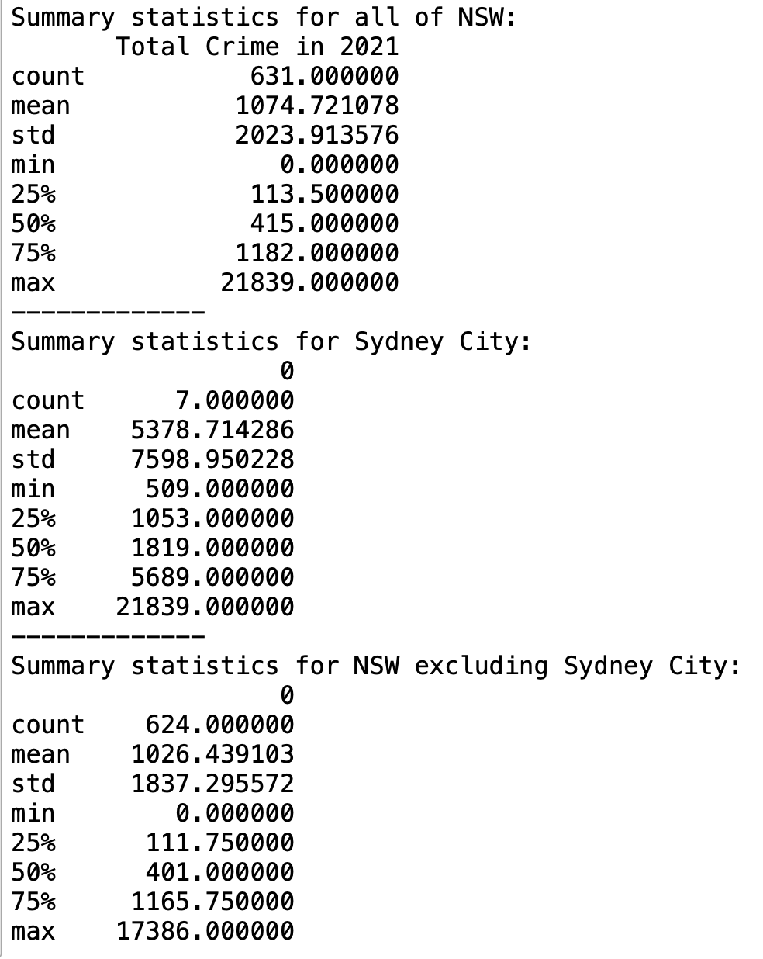

*Figure 5 : Data summaries of crime dataset*

## 3.3 Income

500545654 was responsible for the handling of income data. Average income per citizen per postcode was chosen as a quality of life indicator as it highlights an individual’s level of economic empowerment.

### 3.3.1 Income Dataset Explanation

The “Income” dataset was sourced from the Australian Taxation Office, published by the data government agency [7] which provides the average and median amounts of key items in dollar amounts for each postcode in Australia.

It has a size of 7470 rows x 34 columns with a wide format structure- there is a column for each variable (i.e. “income”, “Average net rent”) relating to the identifier/ primary key column (postcode). Hence, the schema can be described to have a format that is a “collection of observations which all have the same structure”.

| Official Title | *Taxation Statistics 2016-17: Individuals - Table 25* |
| --- | --- |
| License | Creative Commons Attribution 2.5 Australia |
| Data Published | 2019-01-07 |
| Publisher/Agency | Australian Taxation Office |
| Landing page | <https://data.gov.au/data/dataset/540e3eac-f2df-48d1-9bc0-fbe8dfec641f> |
| Data Portal | data.gov.au |
| Jurisdiction | Commonwealth of Australia |

*Figure 6: Metadata for income dataset*

**Source of data and its chain transmission**

This is a secondary dataset collected for the Australian Taxation Office for the financial year of 2016/17 (2016-07-01 to 2017-06-30) on information provided from published accounting statements and reports of Australian government and their authorities. It was collated on behalf of a range of stakeholders by departments of local and state governments including individual citizen data (the data of interest). It was published in the “data.gov.au” data portal with a Creative Commons Attribution 2.5 Australia license. Under this license we are free to adapt this data and build upon it, provided that we provide appropriate credit, provide a link to the license and indicate if changes were made.

**The dictionary for this dataset is as follows*:**

*Note that original dataset has 34 columns. For brevity, only 3 are shown with “Postcode” and “Average total income or loss” being the most important.

| Heading | Meaning | Data Format | Data Description | Example |
| --- | --- | --- | --- | --- |
| Postcode | Integer |  | This is a value with up to 4 digits and indicates geographical sorting data in Australia. This is the primary key in the data. | 2340 (Postcode for Tamworth, NSW) |
| Number of individuals lodging an income tax return | Integer |  | Describes the number of individuals lodging an income tax return **per each postcode in Australia/** |  |
| Average total income or loss | Integer |  | Dollar amount income or loss earned per average citizen per postcode. |  |

*Figure 7 : Data dictionary for income dataset*

### 3.3.2 Income Dataset Quality Assurance

**Cleaning data (Appendix**

Three main steps were taken to clean the data:

1. A copy was created of the original dataset
2. Unnecessary columns in the original dataset (i.e. Number of individuals lodging an income tax return) were dropped by creating a copy with columns of importance (i.e. Postcode' and Average total income or loss',). This was done by creating a new dataset by referring to existing columns : just_income = income[['Postcode', 'Average total income or loss']]
3. Duplicate postcodes were dropped as the postcode column was the primary key, and each value had to be unique. The pandas function for this was .drop_duplicates.(subset=None, keep='first', inplace=False, ignore_index=False) with the following parameters.
4. Null and empty values of income values were dropped using the .dropna() function

The cleaned dataset had a size of 2472 rows × 2 columns.

### 3.3.3 Income Dataset Python Analysis Description

3 key data summary statistics were created. See Appendix G.3 for python code.

1. Grouped-Aggregate summary

An analysis was conducted to compare the average income in Inner Sydney City Suburbs (Postcodes from 2000-2011) against the rest of NSW, as it was hypothesized that this area had a higher income than the rest of NSW.

This summary was created by using a **python function** where .loc was used to refer to the named index of the desired column (ie. Postcode). Then most importantly the **.between function** was used which allows pandas to filter between chosen values of postcodes (2000 and 2011) and **.mean()** was used to find the average of the filtered values.

**Code:**  return incomecleaned8.loc[just_income['Postcode'].between(x,y), 'Average total income or loss'].mean()

To then find the average for the **rest of NSW**, the **~** operator was inserted within the .loc arguments to convert the referenced “Postcode” column as false in Boolean form such that the python averages everything else except the postcodes between 2000 and 2011.

**Code:** return incomecleaned8.loc[**~**just_income['Postcode'].between(x,y), 'Average total income or loss'].mean()

The following results were obtained:

|  | Average Income ($) |
| --- | --- |
| Sydney City | 79383 |
| Rest of NSW | 57663 |

*Figure 8 : Income grouped by inner Sydney City compared to the rest of NSW*

Understanding of the above data creates an overall picture of income inequality across NSW, informing state governments on employment boosting policies that can be introduced across particular postcodes to improve quality of life.

2. Maximum and Minimum income and its corresponding postcode

The .loc was used to refer to a named index and the function idxmin/idxmax was used to find the maximum and minimum value,

|  | Income ($) | Postcode |
| --- | --- | --- |
| Maximum | 239276 | 2108 |
| Minimum | 20,911 | 2308 |

*Figure 9 : Maximum and Minimum income and their corresponding postcodes*

3. Median Income   
  
Median income across NSW is $53,907.5. This value can be compared to the average income across NSW to better understand income inequality across the state and how this corresponds to quality of life. For this, the **.median()** function was used.

**Strengths and Limitations of dataset**

Strength

A clear strength of this dataset was the lack of null and missing values for each correlating postcode. This will allow for a more accurate aggregate data analysis of how income better correlates with quality of life without having to delete incomplete records. For example, as a data analyst, we can gauge a more accurate median income for NSW. This is more technically and time efficient, as there is now a lower number of lines required to clean the dataset.

Limitations

A limitation of this dataset is inaccuracies that may occur due to non-sampling errors which arise from inaccuracies in collecting, recording, and processing the data. Specifically, for taxation results, record holders (i.e. accountants) could have misreported income data such that taxable income was lower, leading to figures that are lower than expected in the summaries provided below. Further, even though Australia has consistent accounting standards that comply with GAAP, some accountant records may deviate slightly. These deviations are written in the “Explanatory Note” component of each accounting statement and interpretation amongst data records may vary leading to the inaccurate collection of income data .

However, the ABS aims to mitigate these errors by working alongside data providers and creating training programs to properly educate data-handling staff on efficient data processing procedures [8]

## 3.4 Immunisation Rates

520617829 was responsible for the handling of immunisation data. Here the relationship between the immunisation rate of 1 year olds and quality of life is examined. Immunisation and vaccines help in decreasing mortality, eradicating diseases and reducing long term expenses on healthcare which makes it a fairly good indicator of health and quality of life.

### 3.4.1 Health Dataset Explanation

The raw data was in .xlsx format with 5 tabs and a table of contents, only tab 4 of this data was used as it made integration of data in later stages easier and succinct. The data dictionary is as follows:

| Field Name | Data Type | Description | Example |
| --- | --- | --- | --- |
| State | Text | Name of State | NT |
| Postcode | Integer | Postcode | 0800 |
| Associated Residential  areas | Text | Associated Residential  areas | Darwin |
| Reporting Year | Integer | Year of data being recorded | 2016-17 |
| Age group | complex | Age group of children fully immunised | 1 year |
| Percent fully immunised(%) | Float | Percentage of children in each postcode fully immunised | 90.0-92.4 |

*Figure 10 : Data dictionary showing metadata information on health dataset*

This dataset (Immunisation Rates for children) was collected from the Australian Institute of Health and Welfare (AIHW) and Australian Immunisation Register (AIR) Statistics [9]

Abstract:

The (cleaned)dataset contains the rates of immunisation of children age 1 in New South Wales by postcode for the period 1st April to 31st March, assessed at 30th June.The definition of fully immunised for one year old as mentioned in the raw data the source of which is mentioned above is - ”that a child has received three doses of diphtheria, tetanus and whooping cough (DTPa) vaccine, three doses of polio vaccine, three doses of hepatitis B vaccine, two or three doses of Haemophilus influenzae type B vaccine, and three doses of the pneumococcal conjugate vaccine. It is assumed that all previous vaccinations were received”. (see Appendix E.1)

Permission:

Most datasets on “AIHW” website are available for public use, and so was the raw dataset used. It was originally published on MyHealthyCommunity website.

The dataset comes under media releases but the exact licence was unable to be obtained; the information on “AIHW” websites being available for public use was found on the “AIHW” website >About our data>Data governance. “AIHW” data complies with the Privacy Act 1988 and Australian Institute of Health and Welfare Act 1987.(see Appendix F.1)

Constraints:

The final dataset produced was for years 2016-17 whereas other datasets in the integrated data were published for 2021 kindly note that this may result in a few confounders in our observations. There is also no direct causality between rate of immunisation and health which could bring about more confounders in ensuring quality of life.

### 3.4.2 Health Dataset Quality Assurance

Data Quality Reports:

1. Tab 4 of the raw data rows in “Percent fully immunised(%)” contains NP values which are not available for publication as there were fewer than 26 registered children or children were not immunised from ages 1 and 5 inclusive(see Appendices G.1, G.2 and G.3) , these values were removed so that data more suitable for integration could be produced.
2. Tab 4 of the original dataset was cleaned by taking out NP values and filtering data by New South Wales(State), 1 Year(Age group),2016-17(Reporting year) and removing all columns except “Postcode” and “Percent fully immunised (%)” so that data would be succinct, readable and easy to integrate.
3. All of this was done using Python and Pandas (see Appendix B.4)

### 3.4.3 Health Dataset Python Analysis Description

Some very basic operations were performed on the clean data such as:

1. Grouping postcodes by the percentage of 1 year olds that are fully immunised
2. Finding the frequency of “Percent fully immunised(%)”
3. Plotting a histogram on the frequency
4. Median of frequency

19.5

1. Standard deviation of frequency

69.40512537681514

1. Mean of frequency

55.25

1. The maximum frequency of percentage range of children immunised

177

1. The minimum frequency of percentage range of children immunised

1

1. Total frequency of percentages or total number of values

442

The code used to produce this summary was implemented in Python (see Appendix C.4)

# **4. Data Integration**

**Data Schema**

The final dataset was integrated using the pandas merge function with a common attribute “Postcode” column to create the following schema (Appendix H.1) :

| **Quality_of_life_indicators** |
| --- |
| Postcode (int 64)  Total crime counts (int 64)  Total public transport stop counts (int 64)  Average income (int 64)  Percent fully immunised(%) (object) |

*Figure 11 : Data schema for integrated data set*

This integrated dataset has a statement of appropriate metadata that describes the data structure, the data meaning, and the data provenance.

**Meta Data**

Name : “Quality of Life indicators for each postcode in NSW”

Authors : 500545654, 520644847, 520392823, 520617829

Legal rights: Data was collated based on Creative Commons Attribution 2.5 or later, which provided authors full permission to manipulate and integrate dataset as done below.

Data structure: Wide format with a size of 440 rows x 5 columns

| **Column name** | **Units** | **Data meaning** | **Data provenance (Refer to Section 3 for references)** |
| --- | --- | --- | --- |
| Postcode | Integer | Unique postcodes based on NSW, Australia.  This is the common attribute that was used to join all of the 4 datasets. | This was a part of each individual dataset when downloaded from respective sources |
| Total crime counts | Integer | This is the sum of all types of crimes that have occured in a postcode, grouped by each postcode. | Raw data originated from BOCSAR. |
| Total public transport stop counts | Integer | Data set includes how many public transport stops there are for each postcode | Transport NSW |
| Average income | Dollars | Average income per each postcode | Australian Bureau of Statistics (ABS) |
| Percent fully immunised (%) | Percent | Proportion of population immunised means the proportion that has received a certain set of vaccines as per AIHW guidelines. | Australian Institute of Health and Welfare |

*Figure 12 : Metadata for integrated dataset*

Python (Appendix H.2)

To integrate this dataset, **a nested pd.merge()** function was used using an “inner join”. The code had the following parameters: pd.merge( dataframe_1, datframe_2, on=”common column”, how=”type of join”). This inner join ensures that a common column is used and all the common postcode rows are joined, meaning that some postcodes that didn’t exist in ALL data frames were dropped. The Postcode column in all datasets were named to ‘postcode’ to ensure that it was consistent.

Challenges

There were 3 main challenges that were faced when creating an unified dataset:

1. The primary key, “Postcodes”, were of different data types amongst all different group members with some having integer, string, and object types. For those that didn’t have integer types, the datasets were individually converted to integer type using the function .astype (See Appendix D for example)
2. Data column names for postcode was different, which would render the pd.merge() function useless. This was rectified by renaming the column such that the name for postcode was similar across each of the 4 datasets using the function .rename() function i.e. transport.rename(columns = {'POSTCODE':'postcode'}, inplace = True)
3. Column names, individually, were meaningless (i.e. “COUNT”), and these were renamed such that further context was provided to our overall analysis of correlating particular indicators with quality of life. For example “COUNT” was changed to “Total public transport stop counts”.

**Final comments**

The final data set provides non-standardised quality of life indicators for postcodes available in NSW. This final score per postcode can standardised (I.e. by creating a Z-scores for each attribute). These scores can be used by decision makers such as state governments to improve aspects such as income inequality, security and health issues, as well as transport inequality to improve the quality of life for each area of postcode in NSW.

Note that due to the use of an inner join (Appendix P.2), the number of rows were reduced to 440, despite some original datasets before merging had 2000 rows (See 3.3.1) indicating that some postcodes from NSW were not included in our overall dataset due to discrepancies between postcode recording amongst organisations.

# 

# **5. References**

[ 1 ] - UNICEF. (2013, April). *Child well-being in rich countries: A comparative overview*. unicef-irc.org. <https://www.unicef-irc.org/publications/pdf/rc11_eng.pdf>

[ 2 ] - Economic and Social Research Institute (ESRI). (2016, July 13). Quality of life problems differ by age group and social class. esri.ie. <https://www.esri.ie/news/quality-of-life-problems-differ-by-age-group-and-social-class#:~:text=The%20paper%20focuses%20on%2011>

[ 3 ] - Transport NSW. (n.d.). *Using QR codes and stop IDs*. transportnsw.info. <https://transportnsw.info/plan/help-with-planning/using-qr-codes-stop-ids>

[ 4 ] - Community Relations Division, freecall 1800 685 449, & Justice, N. D. of. (n.d.). *Offence Open Data*. Www.bocsar.nsw.gov.au. <https://www.bocsar.nsw.gov.au/Pages/bocsar_datasets/Offence.aspx>

[ 5 ] - Explanatory Notes, <https://www.bocsar.nsw.gov.au/Pages/bocsar_crime_stats/bocsar_explanatorynotes.aspx>.

[ 6 ] - BOCSAR. “Open Data.” NSW, BOCSAR, <https://www.bocsar.nsw.gov.au/Pages/bocsar_datasets/Datasets.aspx>

[ 7 ] - Australian Taxation Office . (2019, March). *Taxation Statistics 2016-17: Individuals - Table 25* [Dataset]. NSW Government Data. <https://data.gov.au/data/dataset/taxation-statistics-2016-17/resource/d2804aa6-4c32-453c-9d60-d957e9028952>

[ 8 ] - *5506.0 - Taxation Revenue, Australia, 2016-17*. (n.d.). Retrieved September 11, 2022, from <https://www.abs.gov.au/Ausstats/abs@.nsf/0/72BA81C40E3E0C7BCA2583E80013F68E?OpenDocument>

[ 9 ] - *Immunisation rates for children in 2016–17*. (2018, March 22). [Dataset]. Australian Institute of Health and Welfare. <https://www.aihw.gov.au/reports/immunisation/immunisation-rates-for-children-in-2016-17/data>

‌

# Appendices

## A.1 Transport Dataset Links

Original Transport Dataset, and .txt file used in this report, respectively :

<https://opendata.transport.nsw.gov.au/dataset/timetables-complete-gtfs>

<https://transitfeeds.com/p/transport-for-nsw/237/latest/file/stops.txt>

## B.1 Transport Dataset Cleaning

The Transport Dataset was cleaned using Python :

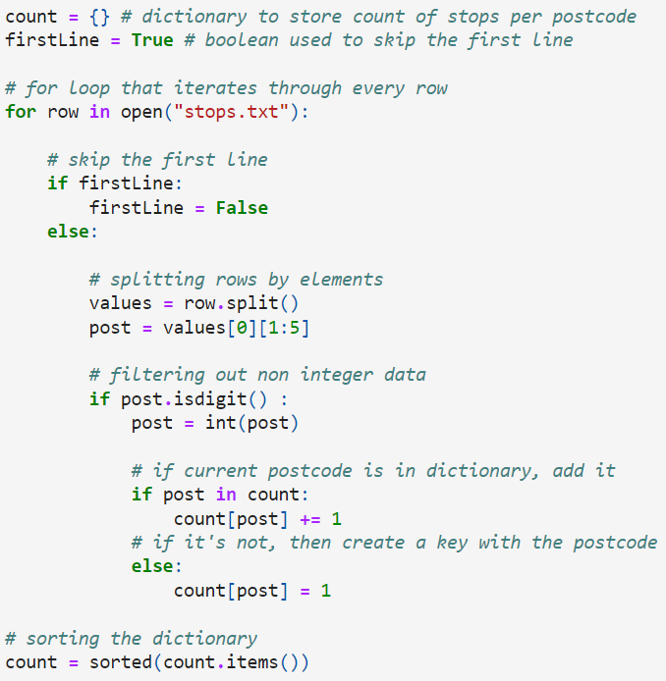

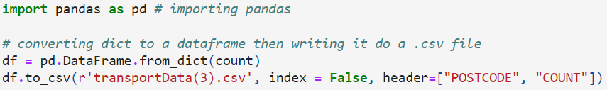

## B.2 Crime DataSet Cleaning

### B.2.1

To clean this data I deleted all columns except Postcode and Jan-21 to Dec-21. The code I used to do this is as follows :

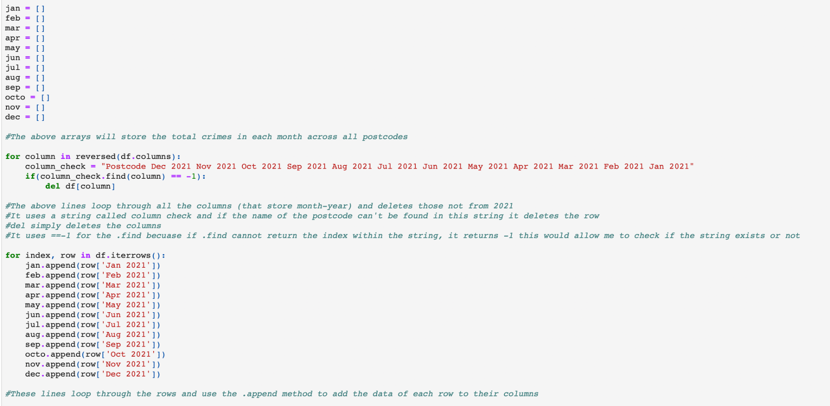

### B.2.2

I summed up the data every 62 values. The code I used to do this was as follows

Created the sum array that records sums of each column :

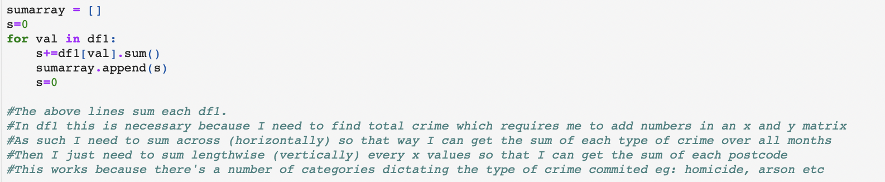

### B.2.3

Summed up the row sums and recorded them every 62 values :

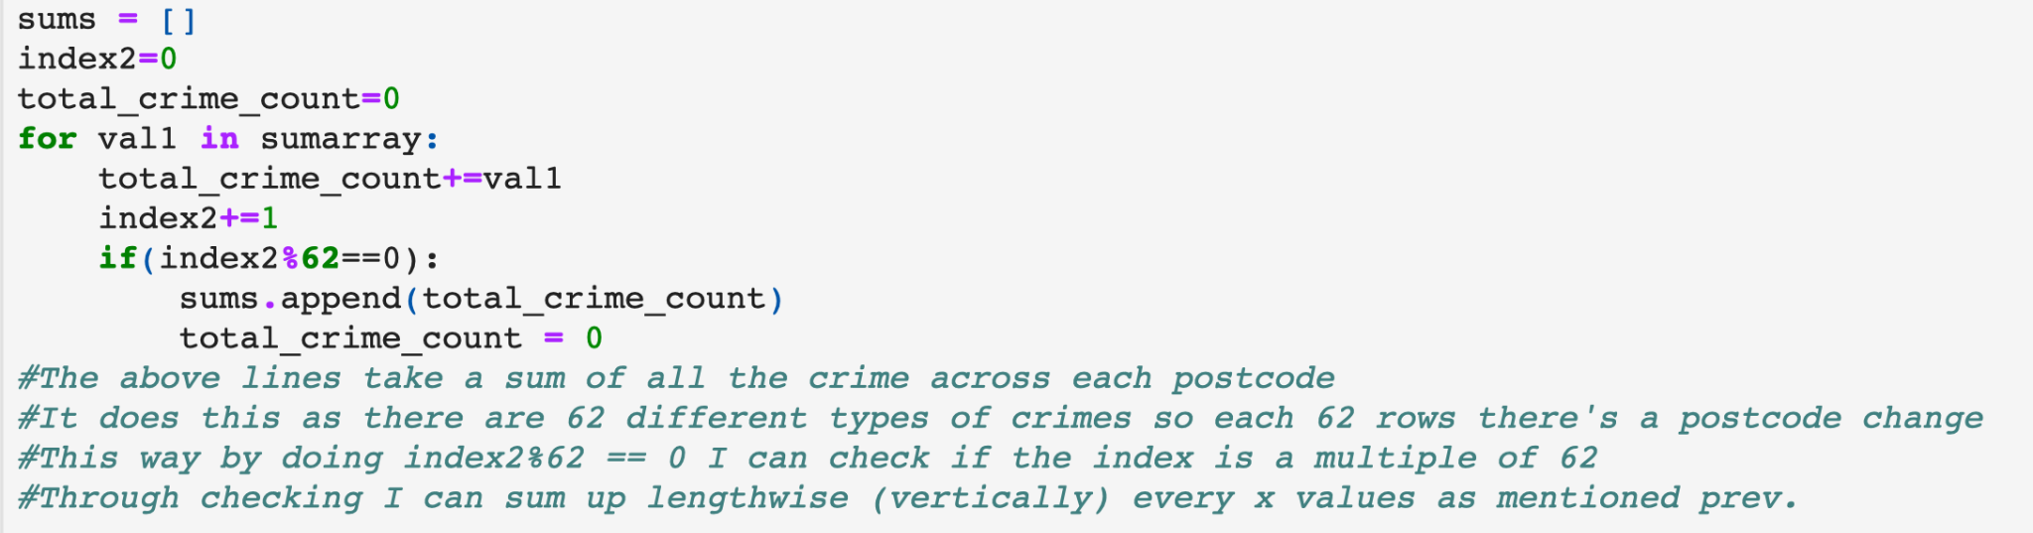

### B.2.4

Recorded all unique postcodes

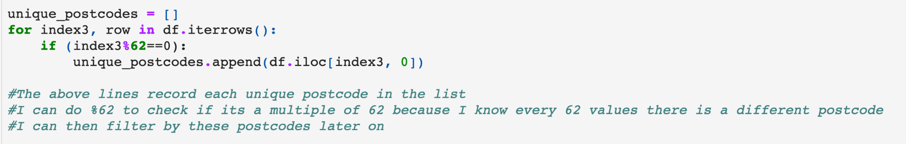

### B.2.5

Stored Postcodes and Total crime as a key: value pair in dictionaries

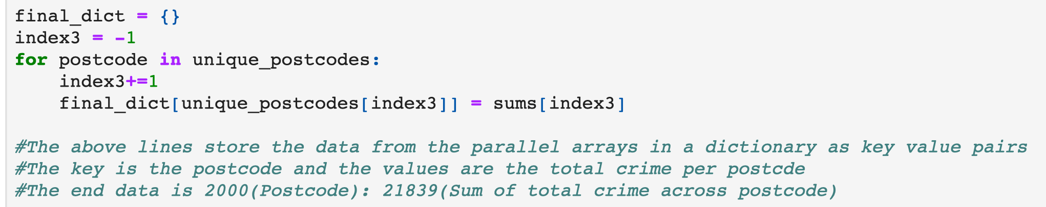

## B.4 Health DataSet Cleaning

Code used to clean data:

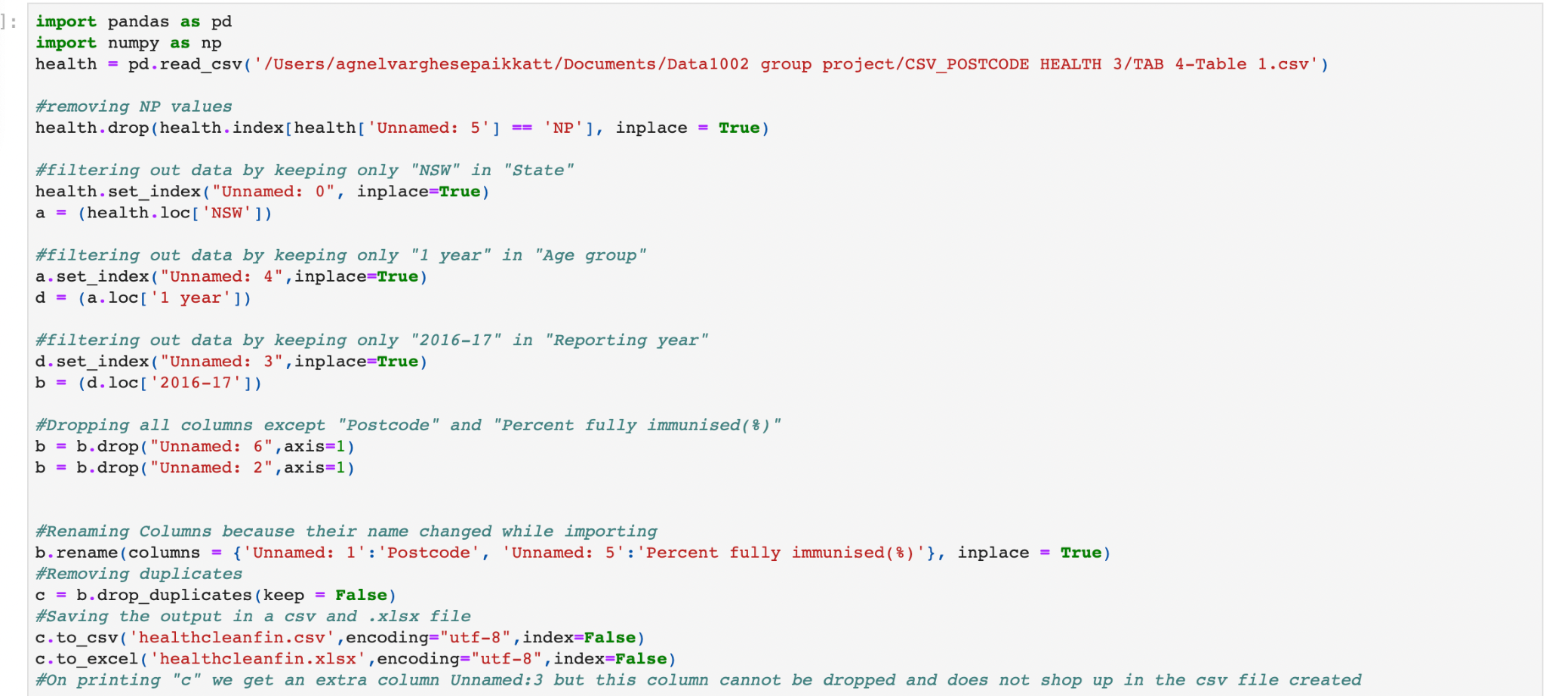

## C.1 Transport Dataset Analysis

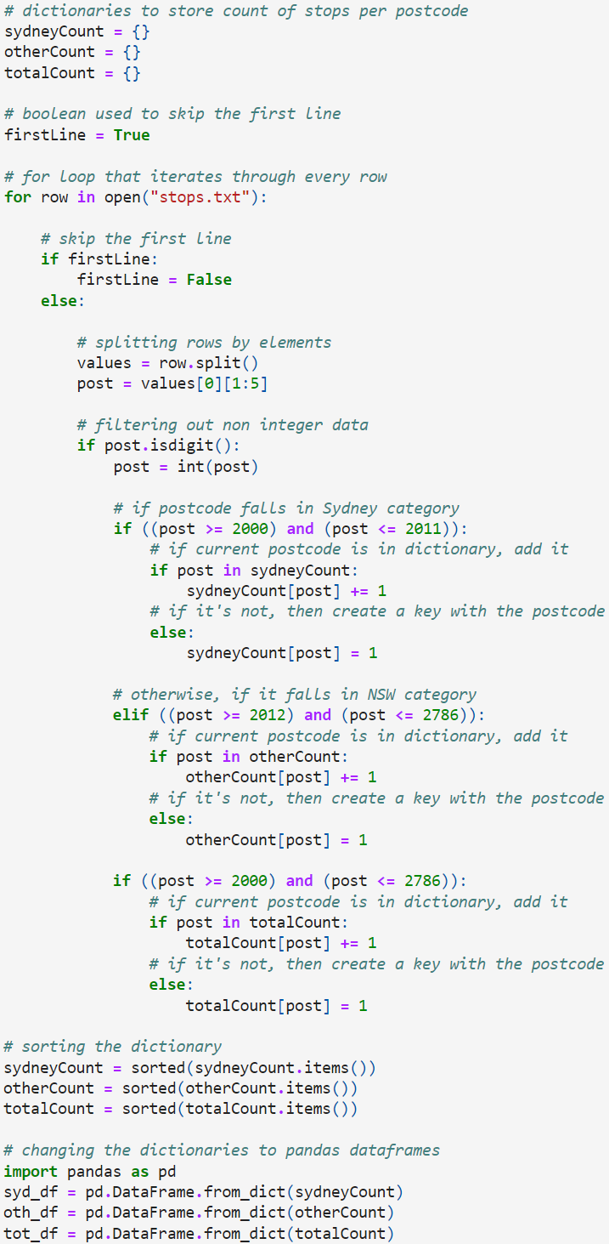

## C.2 Crime Dataset Analysis

Calling .describe on each of the respective data frames to output summary statistics

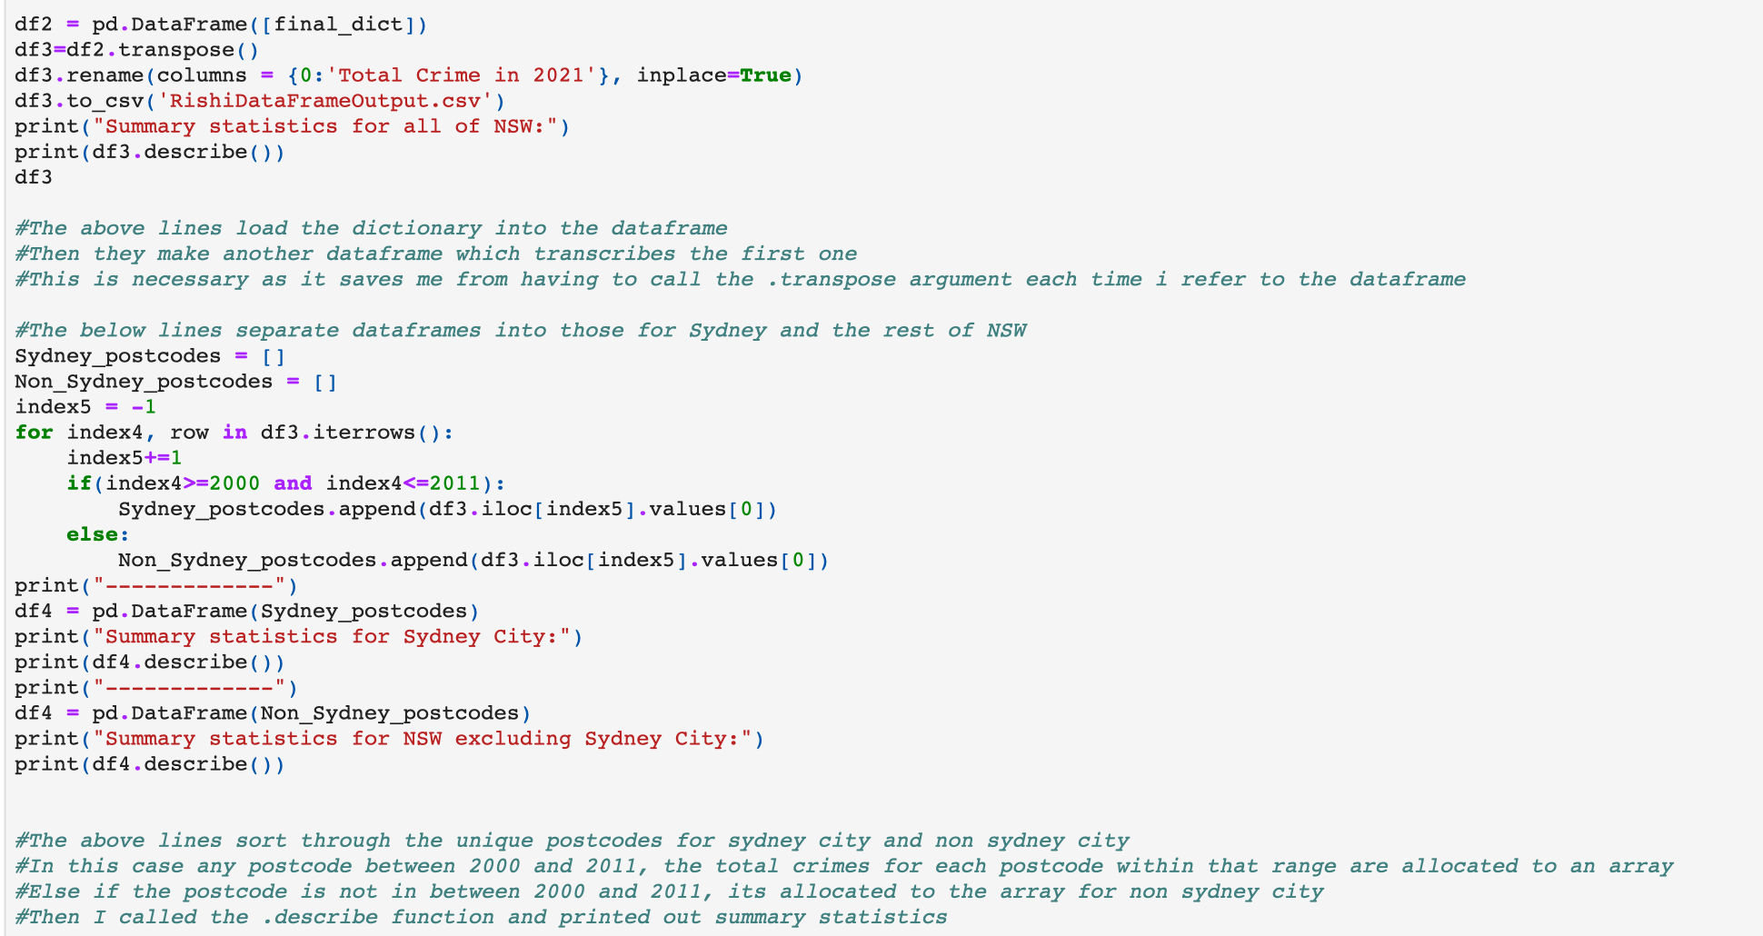

## C.4 Health Dataset Analysis

Code for data summary:

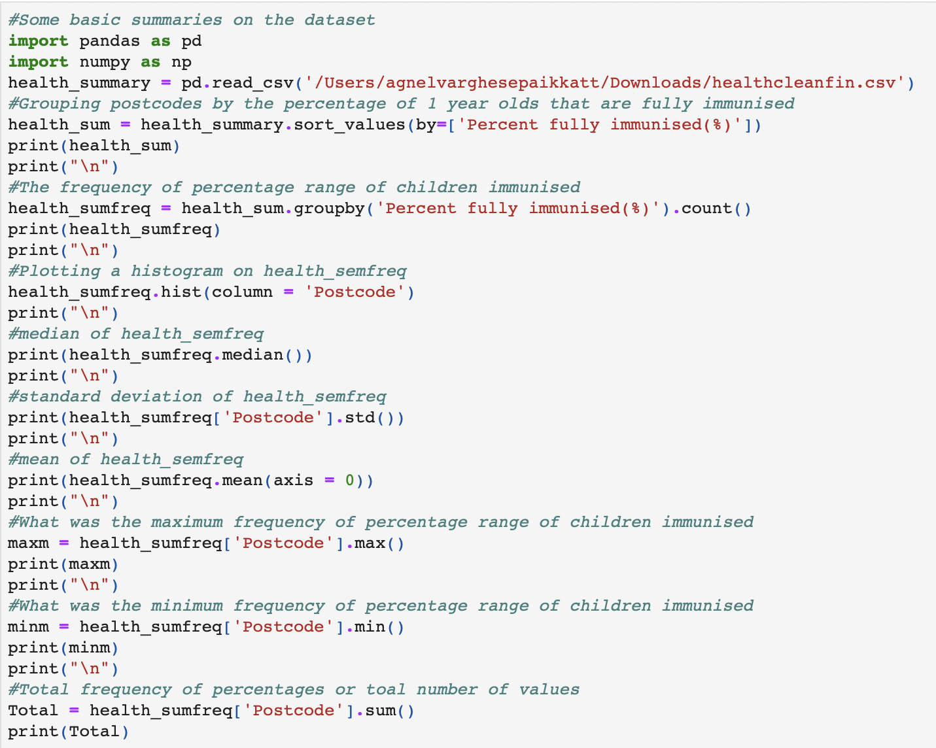

## D. Converting to integer types



## E.1

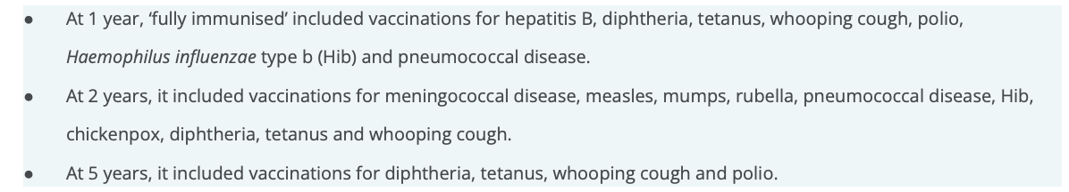

## F.1

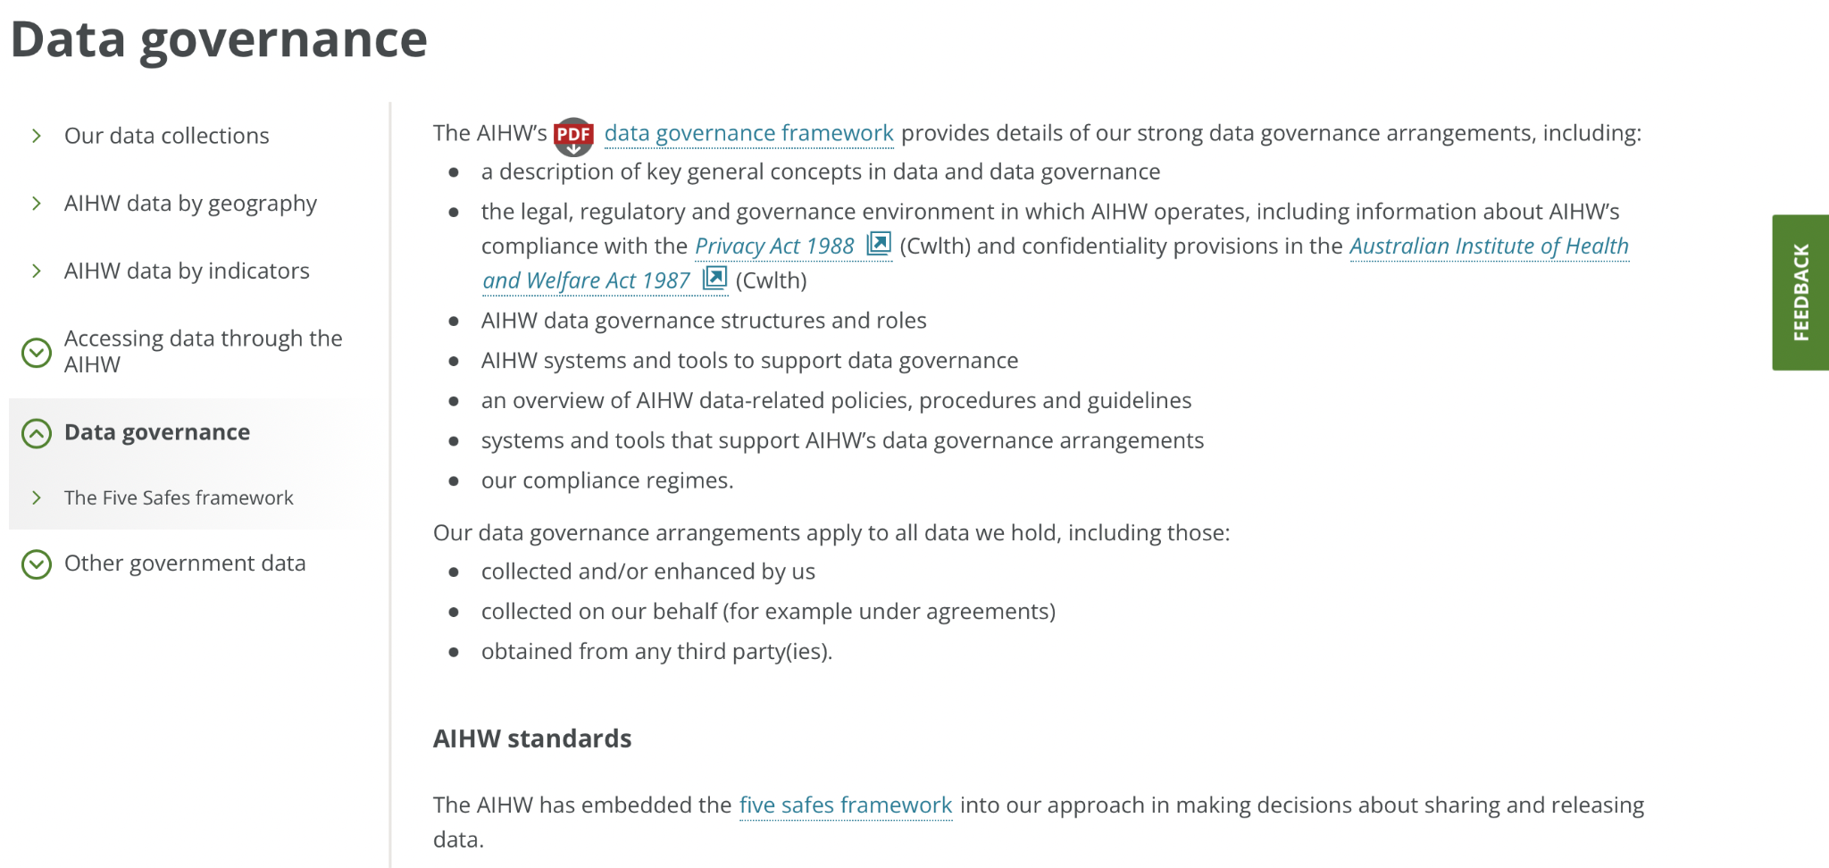

## G.1 Description of NP values

## G.2 Income cleaning code

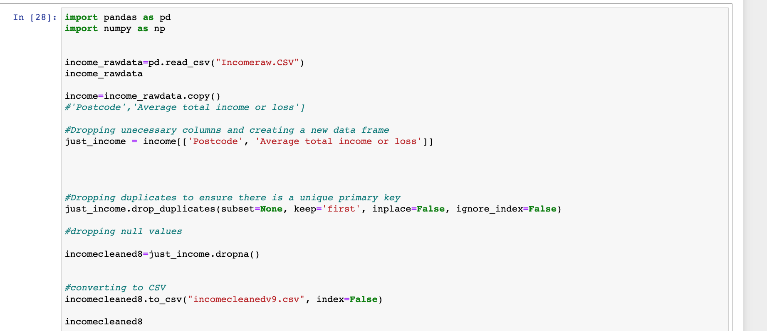

### G.3 Income Summary 1.

Group aggregation (Inner Sydney vs rest of NSW)

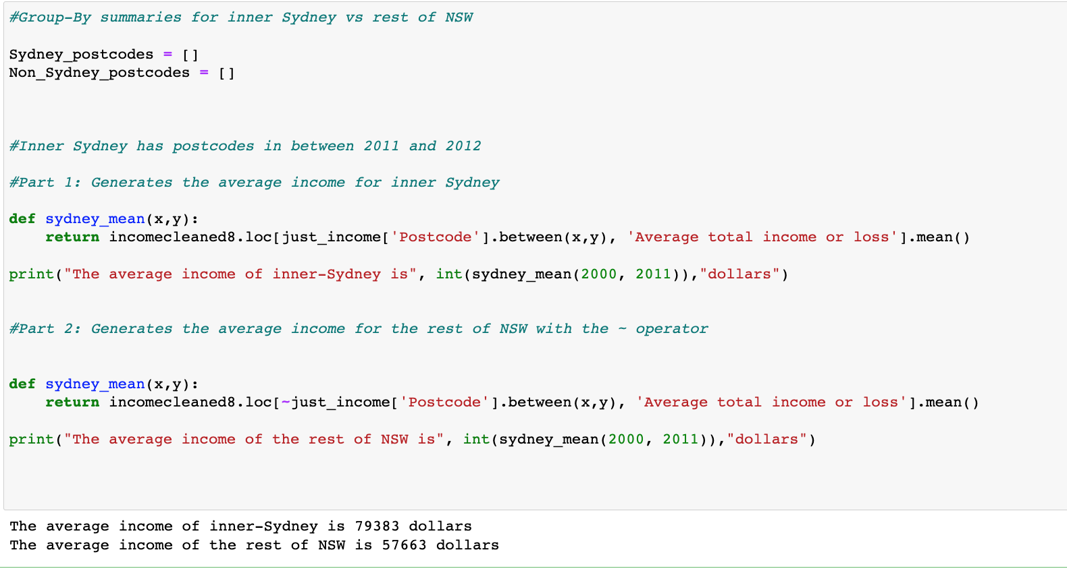

### G.3 Income Summary 2.

Maximum/ minimum data

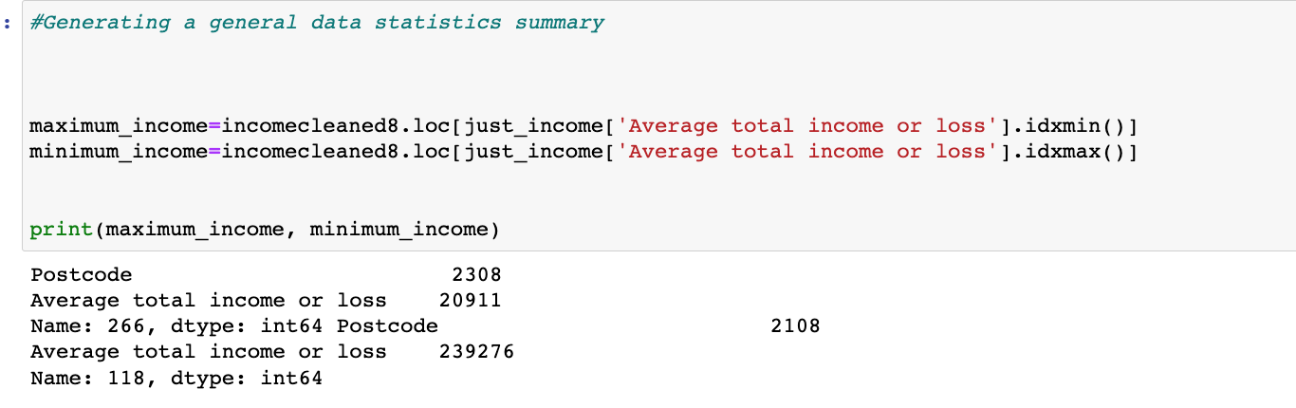

### G.3 Income Summary 3.

Median data for NSW



## H.1 View of integrated dataset

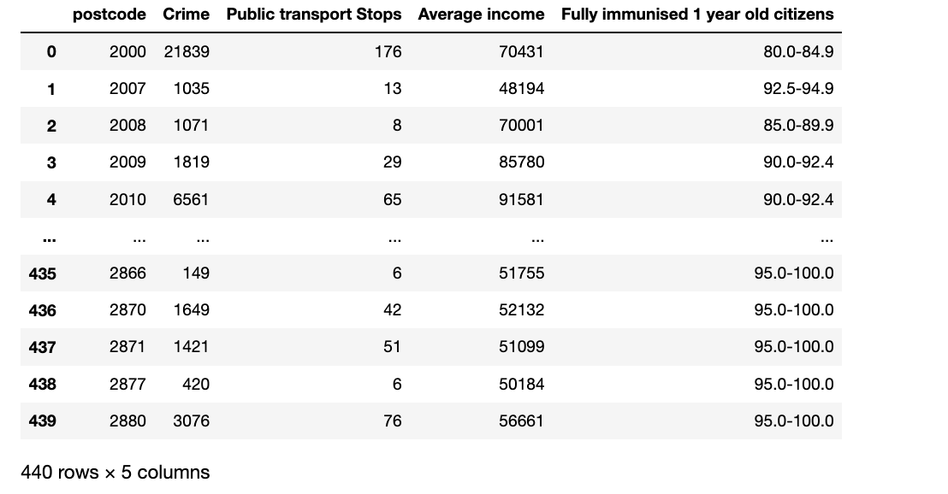

## H.2 Python Code

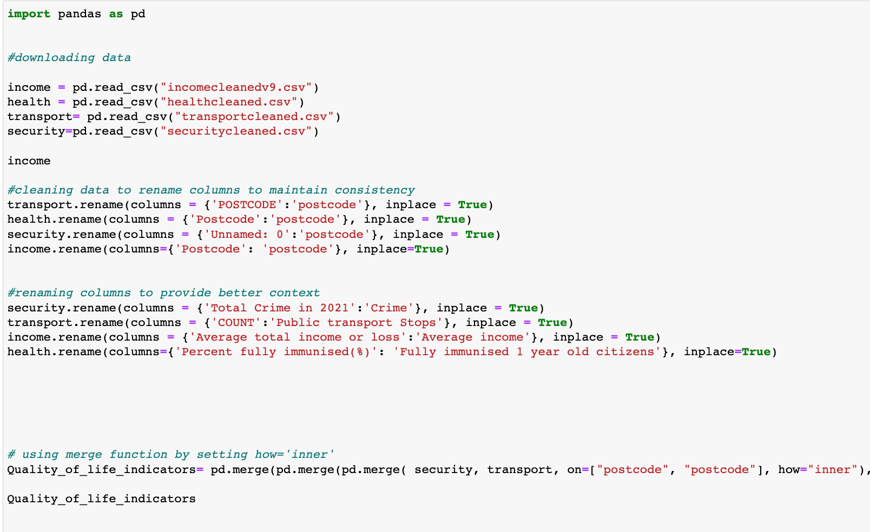

1. [https://www.transitfeeds.com](https://www.transitfeeds.com/)